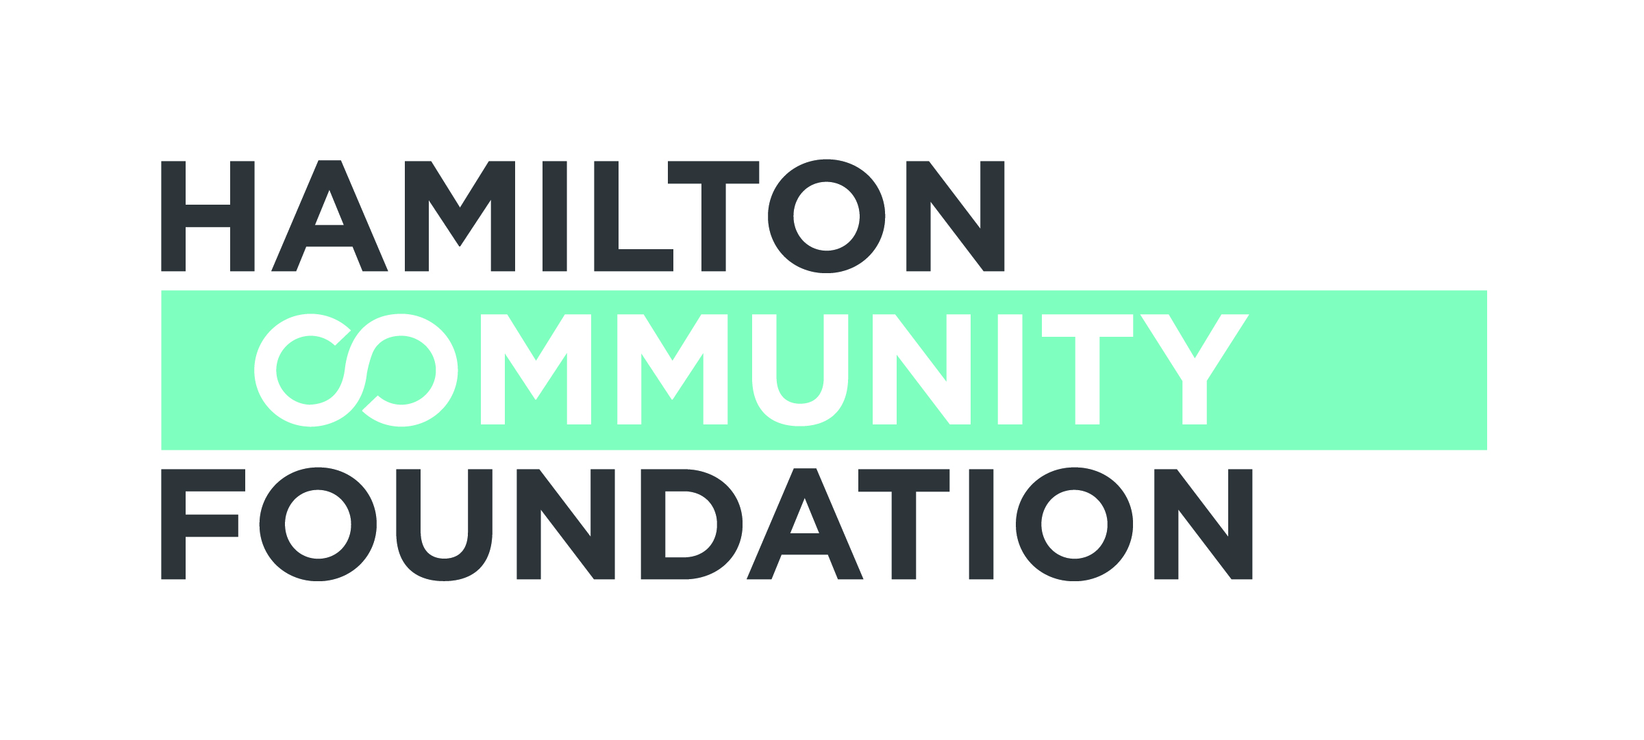

CALL FOR PROPOSALS/GUIDELINES - 2016-17
Deadline: July 25, 2016

ABACUS is an initiative of the Hamilton Community Foundation and the Fairmount Foundation aimed at supporting the academic success and post-secondary access of youth experiencing multiple barriers. ABACUS is based on the understanding that decisions and supports that affect high school success and lead to participation in post-secondary education begin early in a youth’s academic life; that successful interventions should begin as early as middle school. It is also based on research that shows this age group is currently underserved. Therefore, ABACUS will fund programs that begin in the middle school years and focus on improving the academic, community and environmental factors that have the most direct impact on students’ likelihood of succeeding academically and ultimately attending post-secondary education.

The overall goal of ABACUS is to:
Improve high-school graduation rates and access to post-secondary education, including trades and apprenticeship opportunities, by focusing on the “middle-school years”:
Grades 6, 7, 8 and transition to 9.

Hamilton Community Foundation is directing its unrestricted funds to ABACUS. We invite charitable organizations in Hamilton to join us in this work. For 2016-17 granting from the Community Fund will support education-based initiatives aimed at improving middle school years academic and social engagement, improving transitions from middle school to high school and laying the foundation for successful high school graduation and access to post-secondary education for disadvantaged students.

We are especially interested in programs that:

- Serve youth who have been shown to experience more barriers to success in middle school, high school graduation and post-secondary access such as low-income students, first-generation PSE attenders, Aboriginal students, students from newcomer communities etc.
- Operate in partnership with other community or school supports
- Are consistent with the four-pillar framework (outlined following) of academic, informational, counselling/mentoring and financial supports for disadvantaged middle-school aged youth
- Incorporate strategies to engage parents

Through ABACUS and its granting approach, HCF hopes to create a unifying vision that will generate new partnerships, reallocate resources and reorganize programs and resources to create a more co-ordinated and integrated system in Hamilton that will better serve the needs of students in the middle-school years.

The Four Pillars

Research shows that the most effective early intervention programs contain components from these four broadly defined “pillars”:
- Academic upskilling. Academic achievement includes those programs/initiatives that support youth to obtain the necessary grades, skills, and self-confidence to succeed in middle school and move forward in their high school and post-secondary education. Examples could include afterschool homework or academic programs, computer literacy, aspirational and experiential learning, tutoring programs.
- Mentoring. There are a variety of forms of support and counseling including adult mentoring, access to community role models, peer mentoring, peer group activities and parental engagement. Examples might include afterschool recreation programs; programs using the arts as a tool for learning; social skills programs; parental engagement strategies; and one on one mentoring programs.
- Goal setting. Students who are making certain decisions about their future are helped by easy access to information about their choices and the corresponding requirements. This pillar includes parental education initiatives, financial literacy, information workshops for parents and youth, support in mapping choices related to high school courses and long-term career goals, and eventually applying for student financial assistance and post-secondary education.
It might include programs that raise aspirations for youth to attend post-secondary education such as academic summer programming, time spent on college/university campuses and career planning.
- Incentives. Financial components are often an important incentive to students to participate in a program that can lead to post-secondary enrollment. For this grant round, examples in this area could include subsidies and incentives provided through supports such as bus tickets, meal programs, or program materials, as well as incentives which reward behavior, marks, etc.

Please note this change from last year:
For 2016-17 we will not have a Letter of Intent process. Registered charities are invited to submit a completed application by July 25, 2016.

We anticipate that grants will range in size up to a maximum of $60,000 and will be one-to-three years in duration.

Organizations that are non-profit but that do not have charitable status, may be eligible to apply under a fiscal sponsorship. Information is available at:
http://hamiltoncommunityfoundation.ca/?s=sponsorship

General Criteria

- Grants for one-time special events, individual student sponsorships, or capital will not be considered.
- All initiatives must be carried out within Hamilton.
- Grants will not be made to promote political, religious, moral or ethical philosophies or for purposes which may be deemed discriminatory
- Foundation funds are not intended to be used to fund programs that are the responsibility of the public through the annual Board of Education budget.

Proposal Assessment:

The following criteria will be used to assess all applications for support from ABACUS:

- Direct relevance to fund priorities
- Interest and commitment to partner with HCF on ABACUS
- Demonstrated capacity and credibility to plan and implement the work
- Evidence of significant involvement in all stages of the project by community members representative of those the project seeks to benefit
- Compelling rationale for the approach proposed
- Sound fiscal policies and a commitment to financial accountability
- Realistic, measurable goals and commitment to ongoing evaluation aimed at continuous improvement
- Potential to leverage additional financial support
- Clear and reasonable budget
- Level of co-operation and collaboration with other groups that could contribute to improved results in the project
- Evidence of community support for the initiative
- Potential model that could be replicated
- Need for Hamilton Community Foundation funding
- Projects should encourage collaboration and create an impact beyond the funding period

Successful applicants will be invited to become part of a Community of Learners and will be expected to participate in evaluation and information sharing activities as requested by HCF.

For more information about ABACUS please visit:
http://hamiltoncommunityfoundation.ca/grants/grant/abacus-advancing-post-secondary-access/

Contact Information:

Hamilton Community Foundation, 120 King Street West, Suite 700,
Hamilton, Ontario, L8P 4V2
Phone: (905) 523-5600 Fax: (905) 523-0741
Website: www.hamiltoncommunityfoundation.ca
E-mail: s.charters@hamiltoncommunityfoundation.ca

