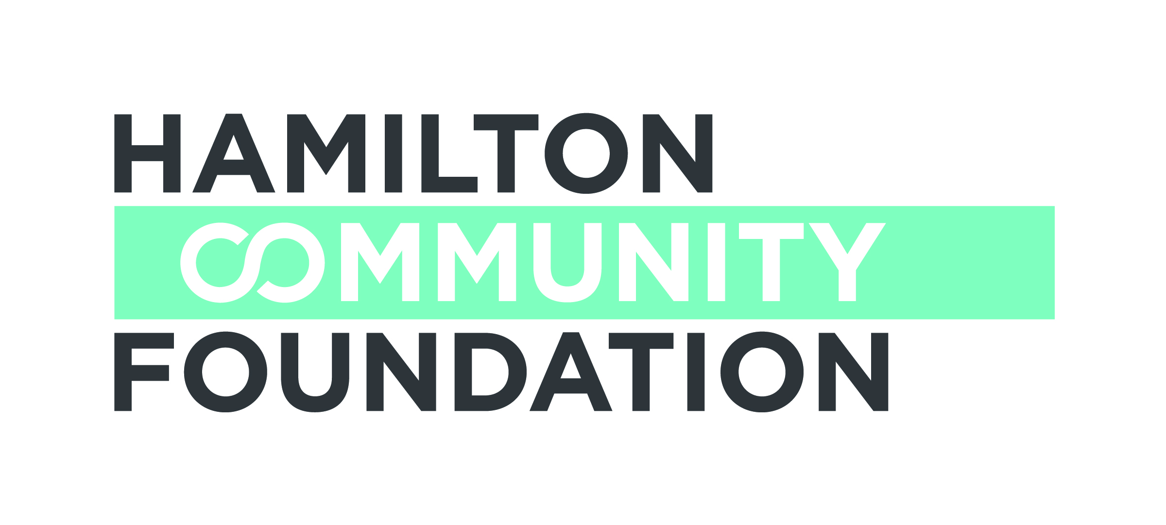

THE SPECTATOR SUMMER CAMP FUND

APPLICATION

Due Date: April 7, 2017

Applicant Information:
NAME OF ORGANIZATION:
ADDRESS:

CONTACT PERSON: TITLE:
TELEPHONE: FAX: EMAIL:

CHARITABLE REGISTRATION NUMBER:
Is this the first time that you are applying to this fund? Yes No
If yes, a competed "Spectator Summer Camp Fund Survey For New Applicants" survey must be submitted.
Name of Camp(s) and Location

1. own rent other

2. own rent other

Please explain “other” (ie: you sponsor children to go to this camp):

(a) Amount requested from Spectator Summer Camp Fund: $

(b) This will provide Camperships (Camp Sponsorships) for children
who reside in Hamilton/Wentworth or Burlington:
- for day camp: (#) children
- for residential camp: (#) children

(c) Cost per session:
- day camp: $ /day X days =
( ie: $ 20 /day X 5 days = $100)

- residential camp: $ /day X days =

- Attach detailed budget for camp program, showing anticipated revenue (donations, grants, fees, agency program funds, etc.) and a breakdown of projected expenses.
Page 1 of 2

(e) Attach brochure(s) about camp(s) or description.

- Attach your organization’s most recent annual financial statement.
- If you are applying for the first time, attach a completed "Spectator Summer Camp
Fund Survey For New Applicants" survey form.

Any additional comments:

11. Authorized Signatures

We hereby make application for a grant from the Spectator Summer Camp Fund and declare that the information provided in the application form and all required attachments are complete with no misrepresentation.

We understand that submission of this application will not necessarily result in funding support from the Hamilton Community Foundation. Furthermore, we understand that applications may be funded in full or in part, and with some conditions. We understand that staff and volunteers of the Hamilton Community Foundation will review our application.

We certify that this application has official approval from the Board of Directors of the applicant organization.

______________________________ _________________________________
Signature, Executive Director of Name /Title (print)
Applicant*

______________________________ _________________________________
Signature, Chair, Board of Directors Name /Title (print)
of Applicant*

*In the event of a sponsorship, the Executive Director and Board Chair of the organization holding charitable status must sign this Application.

If you have any questions or require assistance, please contact Sharon Charters at:

(905) 523-5600 x 242 / s.charters@hamiltoncommunityfoundation.ca
This application form may be downloaded from our website www.hamiltoncommunityfoundation.ca

Applications must be submitted to the Foundation office,
Suite 700, 120 King Street West, Hamilton, ON L8P 4V2 in HARD COPY ONLY. Submissions via email or facsimile will not be considered.

Page 2 of 2

