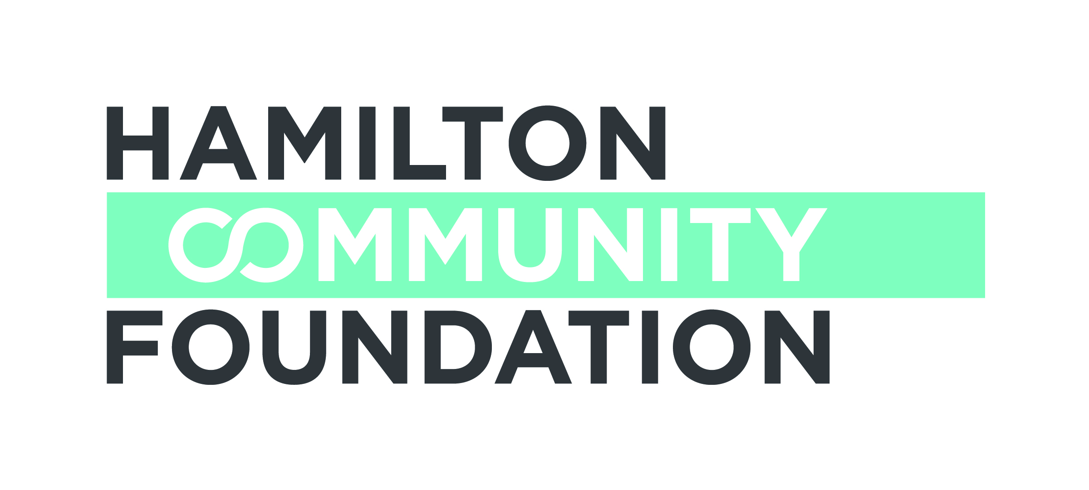

WOMEN 4 CHANGE FUNDD 2017-188
APPLICATION FORM 2
Due Date: January 31, 2018

Please review the fund guidelines before completing this application.

This Checklist forms part of your application to the Women 4 Change Fund. In order for your application to go forward, this form must be completed and signed.

All Applicants:

TWO complete copies of the application (including TWO copies all supporting
documentation of the organization holding charitable status

TWO copies of the project budget

If you are a Community Organization also add:

Signature of the Chair of the Board of Directors and the Executive Director indicating
Authorization of the application by the Board of Directors of the organization holding
charitable status

TWO copies of the partnership agreement between the applicant and the sponsoring
agency, if applicable

TWO copies of list of current Board members, of the organization holding charitable
status

TWO copies of the organization’s operating budget for the current year of the
organization holding charitable status

TWO copies of the most recent audited financial statements of the organization holding
charitable status

If you are a Public Agency (i.e. University, Hospital, School Board, Municipality):

Signature of the Head of the Department implementing the project

Date: ______________________________
Executive Director or Head of Department Signature
______________________________
Chairperson of Board of Directors
(Community Organizations only)

WOMEN 4 CHANGE FUNDD

2017-189
APPLICATION FORM–PART 2 OF 2 2
Due Date: January 31, 2018

Applicant Information
Organization Name:

Address:

Registered Charitable Number:

Telephone: Fax: Website:

Contact Person: Position:

Telephone: Fax: E-mail:

Sponsor Information (if applicable)
Organization Name:

Address:

Registered Charitable Number:

Telephone: Fax: Website:

Contact Person: Position:

Telephone: Fax: E-mail:

Note: A completed and signed Partnership Agreement must be submitted with the application.

Project Information
Project Name:

Total Project Budget: $

Amount Requested: $ over months

Start and completion date for project or note if this supports an existing ongoing program:

Please complete the following:

1. Our overall goal with this project is to:

2. Our workplan including a timeline and the specific steps or activities we will put in place to reach this goal is:

3. Our specific target population is:

4. Explain how this initiative promotes equity and social justice for women and maximizes their health, social and/or economic well-being:

5. We chose this approach because (how is this evidence informed or a new innovative pilot):

6. The people/organizations who will be working with us are:

7. We know this project is needed because (specific, local needs information):
8. We are the appropriate group to undertake this work because:
9. The number of people we will be serving is estimated at:

10. We would also like you to know that:
11. Please complete the following requested budget form (total should equal amount requested):

Item | Details | Amount ($)
Total Amount |  | $

- Other sources of funding for the project:

Source  Organization  Contact Name  Contact Number | Item / Details | Amount | In Kind  or  Financial | Anticipated  or  Confirmed
TOTAL |  | $

13. Section F: Authorized Signatures
We hereby make application for a Hamilton Community Foundation Women 4 Change Fund grant and declare that the information provided in the application form and all required attachments are complete with no misrepresentation.

We understand that submission of this application will not necessarily result in funding support from Hamilton Community Foundation. Furthermore, we understand that applications may be funded in full or in part, and with some conditions. We understand that staff and volunteers of Hamilton Community Foundation will review our application.

We certify that this application has official approval from the Board of Directors of the applicant organization.

______________________________ _________________________________
Signature, Executive Director of Name /Title (print)
Applicant*

______________________________ _________________________________
Signature, Chair, Board of Directors Name /Title (print)
of Applicant*

*In the event of a sponsorship, the Executive Director and Board Chair of the organization holding charitable status must sign this Application

If you have any questions or require assistance, please contact

Sharon Charters at: (905) 523-5600 x 242 / s.charters@hamiltoncommunityfoundation.ca
This application form may be downloaded from our website www.hamiltoncommunityfoundation.ca

Applications must be submitted to the Foundation office,
Suite 700, 120 King Street West, Hamilton, ON L8P 4V2 in HARD COPY ONLY by 4:30 pm. on the application deadline. Submissions via email or facsimile will not be considered.

