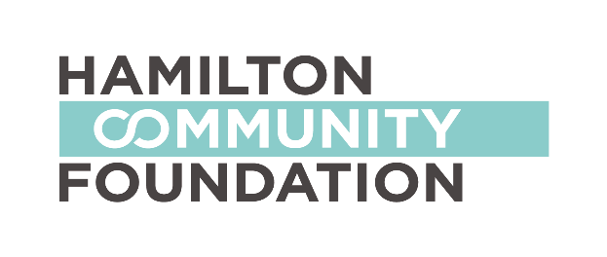
GRANT OPPORTUNITY:
WOMEN4CHANGE

What is Women 4 Change?
Women 4 Change was established in 2012 by a group of local women who came together with HCF in a mission to inspire and enable the women of Hamilton to become leaders in philanthropy, while improving the lives of women and girls in our community through collective giving.
The founders of Women 4 Change envisioned an initiative where contributors would work collaboratively to achieve transformational change. They established a field of interest fund at Hamilton Community Foundation, to which each person contributes annually, as the vehicle through which annual grants to local organizations will be made. Throughout the year a number of educational and social opportunities are provided to enable contributors to learn about philanthropy and the issues they care about. They have established guiding principles to ensure the Women 4 Change initiative grows and develops in a meaningful and informed way.
Granting Framework

Women 4 Change takes a transitioning through the life cycle approach to granting. A life cycle approach to understanding the needs of women recognizes that women’s needs change over the course of their lifetimes. Key transition points of focus for the fund include:
Late childhood/adolescence
Transition to Economic Independence
Motherhood/Family Life
Aging Well

Funding Opportunity

Women 4 Change invites applications from registered charities (or non-profits with a charitable partner) for grants to support initiatives supporting women and girls in Hamilton. It is anticipated that 3-5 initiatives will receive grants up to a maximum of $10,000.

For this year (2018/19) we will focus on the transition point of “Aging Well”.

Initiatives are required to meet the following criteria:
- Fit within the Aging Well life stages framework
- Is based on promising practices or innovative model
- Meets an identified need or gap in service
- Offers the opportunity to help change the trajectory for women at risk

Also of interest are proposals which include a component that educates/supports philanthropic giving.

Grant funds are not available directly to individuals, to support endowment funds, research, deficit financing, conferences and seminars or capital campaigns.

Deadline for Applications: Applications will be accepted until January 31st, 2018. Please note that applications cannot be accepted beyond 4:30 pm. on this date.

More information and the application form is available at www.hamiltoncommunicationfoundation.ca. You may also contact Sharon Charters, Manager of Grants, at 905-523-5600, Ext. 242 or s.charters@hcf.on.ca.

