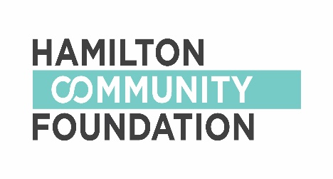
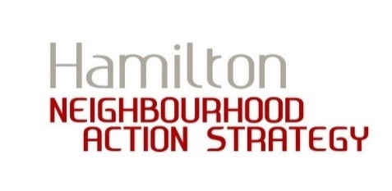
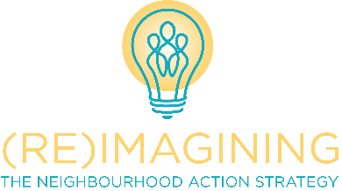

NEIGHBOURHOOD ACTION STRATEGY
SMALL GRANTS PROGRAM

APPLICATION GUIDE – HELPFUL TIPS

Sometimes applying for a small grant can make you feel like this:

We hope this Application Guide can help! This Guide was developed to help you think through and fill out the Application Form. Feel free to read the entire guide or only refer to the sections you need help with.

Note: If you require an interpreter to help fill out your application, please call 905.546.CITY.

Question 1: The Idea!

WHAT is your idea?

Please try to describe your idea. Is your idea an event you want to run? Do you want to purchase a piece of equipment or create a piece of art? Do you want to offer a course, program or activity?

It’s OK if the project changes a bit. Sometimes things don’t go as we plan.

WHERE do you want to host your project or event?

Think about were you want to host your project or event. Some commonly used spaces, and advice on how to access those spaces, are below.

If you need help arranging space, please contact a Community Developer.

Activities on properties operated by the City:

If you are planning to host an outdoor event on:
- City or Public property, such as a park or on a street; OR
- Private property where food and/or alcohol is being served

Then, you will need to complete a special application for the City of Hamilton called a Special Events Advisory Team (S.E.A.T) application. This process can be intimidating, but please don’t be discouraged! Feel free to learn about the process, and apply here:
https://www.hamilton.ca/life-events/hosting-events/seat-guidelines

Please contact a Community Developer for assistance or contact the S.E.A.T. office at the City of Hamilton Tourism and Culture Division:
Email: SEAT@hamilton.ca Telephone: 905-546-4646

If you are planning to use a City-operated Recreation Centre:

Please contact a Community Developer for assistance with the rental, insurance, and fee waiver (yep, it could be free!).

Activities on properties operated by the Public or Catholic school boards:

If you are planning to use a Hamilton Wentworth District Catholic School Board property:

Then, you can apply here: https://www.hwcdsb.ca/support/communityuseofschools/

If you are planning to use a Hamilton Wentworth District School
Board property:

Then, you can apply here: https://www.hwdsb.on.ca/community/partnerships/facilities-partnerships/application/

Insurance and liability:

You will likely be asked to provide liability insurance. There are many ways to get this. If your project takes place on City of Hamilton property, ask a Community Developer to help you arrange “Game Day Insurance”.

If it takes place somewhere else, ask the property owner/administrator to explain the requirements, and ask if you can pay for them to take out additional insurance from their insurer (this is called a “rider”). Also talk to your Fiscal Sponsor to see if they can help.

Why are events such a big deal, anyway?

Special events are an opportunity to invite the entire community to celebrate together. Be encouraging to groups who want to use small grants to share their celebrations for cultural or statutory holiday such as Eid, Easter, or the Strawberry Moon.

Be inventive, too! Inspire new leaders who have new ideas for a special celebration that is their own invention or is an old idea that happens to be new to your neighbourhood, like Winterfest or a summer corn roast.

Question 2: The Need!

Think about your community and your project. Everyone wants their community to be better, and a project idea usually starts there. It might be something in your community that you would like to add or remove. It could be something you need to protect from change, or something you need to maintain. Maybe, it’s something that needs changing or updating.

“We’ve already got one of those already!”
Sometimes something that looks welcoming or inclusive actually isn’t. Trying to make it more welcoming and inclusive would be great, but it might not work out that way for now. Programs and activities are an opportunity to enhance equity in our neighbourhoods, because not all programs are created to serve everyone who is interested in participating. We encourage projects that help meet these needs. Some examples include: all-ages swim for families who have a member who identify their gender as trans or non-binary, or a drop-in coffee social for caregivers with complicated parenting or custody arrangements.

Question 3: The Impact!

What will it be like after your project? What will be added, or removed, protected or changed?

Think about how your project will benefit your community, but also think about how the people participating in planning or leading the project might benefit from the process of doing the work. Will you meet new people, or get to know them better through working on the project? Sometimes that is more important than the actual project!

Question 4: The People!

Project Planning and Leadership:

- A project with one (1) leader can apply for a grant of up to $500.
Please provide a secondary contact for this application, who can be an alternate contact in case the primary person cannot be reached. The secondary contact on an application for a grant of this size is not required to have any additional role or responsibility for the project.

- A project with two (2) or more leaders can apply for a grant of up to $1500. Both the primary and secondary persons on an application for a grant of this size must each have roles in the leadership and planning of the project.

Cross neighbourhood partnership has its rewards!

Partnerships are a great way to increase your resources for even better results. Let’s do the math to prove it! Remember, these are maximum amounts available; you can apply for any amount up to the maximum.

Number of Residents Involved Maximum Funds Available
1 leader from Crown Point $500
1 leader from Crown Point + 1 from non-NAS area $500
1 leader from Crown Point + 1 from Riverdale $1000 ($500 + $500)
1 leader from Crown Point + 2 from Riverdale $2000 ($500 + $1500)
2 leaders from Crown Point + 2 from Riverdale $3000 (1500 + 1500)

Feel free to work with as many neighbours and neighbourhoods as you wish. And use as many different funding sources as you can secure.

Twice the money, half the paperwork! (Okay, maybe just a little less paperwork)

If residents from two (2) or more neighbourhoods want to combine Small Grants funds for a project, they need to apply separately through their respective neighbourhoods. However, they can prepare the Application Form, budget, and Final Report together. Sharing money can be tricky, so think ahead, and have a plan for how you will work together to share responsibility for costs. Also think about how to share money and other resources leftover at the end of the project.

Volunteers and Other Helpers:

Try to find some people to help with your project. Having help means less work for you, but it also means other people can learn from the experience. They might be able to learn a new skill. Or, sometimes it is more important that people working together can also learn how to be a team, or even be friends.

Questions to consider as you’re planning:
- How many people do you think you will need to help you do this?
- What roles will volunteers play?
- Are there any special skills you need them to have?
- Can you find people who have the skills, or can you teach them?

If you are struggling to find or keep volunteers, think about ways that you can support them to be successful. For example, provide training, offer incentives, team up to share tasks, provide mentorship, invite them to contribute their own ideas, etc.

Question 5: The Community!

There are so many businesses, services, and organizations in the neighbourhood, and they have so many skills and resources! Let them know what you are doing, and they might be able to help. If you have a poster or newsletter, drop one off. If you are uncomfortable approaching a stranger, make up a question to ask, and then mention that you have this project. It might sound weird, but it’s actually just being friendly!

Questions to ask as you’re planning:
- Can any local businesses or organizations help?
- Can they promote for you by hanging a poster?

- Can they help you save money by ordering something wholesale, that you pay for?
- Do they have space you can borrow? For example, a kitchen, meeting room, outdoor space, or space in their commercial fridge or freezer.
- Do they have equipment that you could borrow or rent at a cheaper cost? For example, a BBQ, trailer, vehicle, tools, portable tables and chairs, sound system, projector, etc.
- Can they donate products or services? For example, food or printing.
- Which charity could be a fiscal sponsor?

It never hurts to ask!

Question 6: The Timing!

Every project needs a schedule. Create a timeline for your work. It’s okay if you have to make some guesses because timelines need to be flexible. Just remember that your project must be completed within six (6) months of the money being issued to you or by the end of Hamilton Community Foundation’s fiscal year (For the year 2018/2019, that date is March 31, 2019) – whichever date comes first! For projects that need more than six months to complete, please discuss with the Community Developer.

Questions to consider as you’re planning:
- Are there significant dates when purchases must be made? Predicting this will help the fiscal sponsor know when cheques need to be issued.
- Is there a date when you expect the project to be implemented? This could be the first day of a series of classes, or the beginning of an art or construction project that will take more than one day to complete.
- What date do you expect your project to be completed?
- What date can you submit your Final Report and receipts?

Question 7: Sharing!

We have got to tell everybody what you are doing! It is really exciting that you have created this project, you deserve encouragement, and you might need help for things like advertising.

Questions to consider as you’re planning:
- Who needs to know about this project?
- What are the ways you can let them know?

- Do you need help creating materials (e.g. poster or postcards, social media announcements, newspaper articles, etc.)
- Do you need to translate materials into different languages?
- When is the best time to start promoting?
- If you are advertising using mainstream or social media, what date will you need to submit the advertisement for broadcasting?

Question 8: Questions!

Is there a problem with your project that you just can’t find a solution to? Ask in this section of the application, and feel free to ask anything. Your Community Developer and the members of the planning team/hub will try to help.

Fiscal Sponsors

Hamilton Community Foundation can only issue funds to a charitable organization in good standing with the Canadian Revenue Agency (CRA). Grant applicants have the power to choose an organization to partner with as their fiscal sponsor. The mission of the fiscal sponsor must align with the spirit of your small grant. For example, if you want to run a children’s fair, you wouldn’t partner with an organization that only serves seniors.

Questions to ask your fiscal sponsor:
- Does my project align with your mission, vision and values?
- Is your organization in good standing with the Canadian Revenue Agency (CRA)?
- Hamilton Community Foundation commits to processing grant applications within two weeks. What is your turnaround time for issuing a cheque?

Remember to provide your fiscal sponsor with a copy of your grant application so they can understand your project too. Fiscal Sponsors should also receive a copy of your Final Report.

Community Developers, members of the local planning team/hub, and other neighbours can help you choose and talk to a fiscal sponsor! To help you further, there is a template Letter of Agreement in this toolkit, as well as a ‘Frequently Asked Questions for Fiscal Sponsors’ document.

