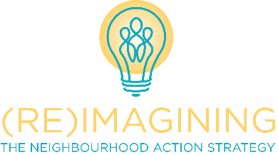
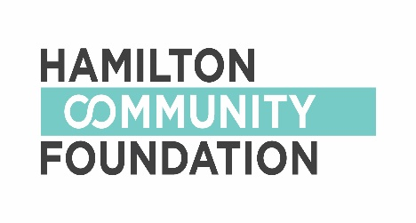
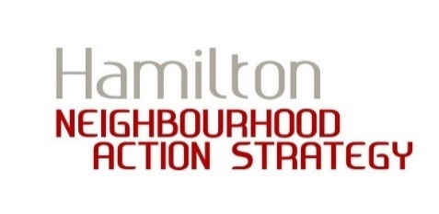

NEIGHBOURHOOD ACTION STRATEGY

SMALL GRANTS PROGRAM TOOLKIT
2018 PILOT

“Cities have the capability of providing something for everybody, only because, and only when, they are created by everybody.”
- Jane Jacobs
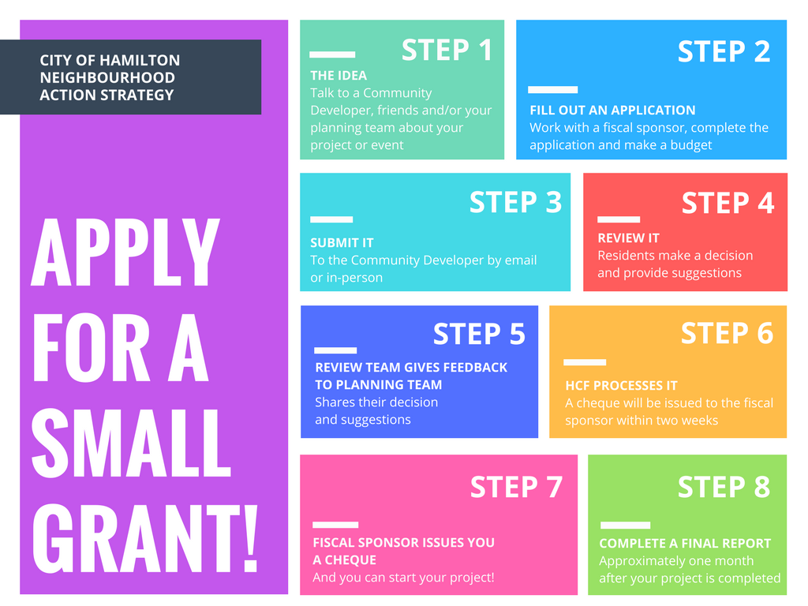

About the NAS Small Grants Program

What is the Neighbourhood Action Strategy?

Hamilton’s Neighbourhood Action Strategy (NAS) is a partnership between the City of Hamilton and Hamilton Community Foundation (HCF). It was launched in 2011 to respond to the social, economic and health concerns of specific neighbourhoods in the City. The NAS supports residents in eleven (11) neighbourhoods as they work toward building healthier communities.

Within neighbourhoods, the NAS sees the needs of diverse communities, including: newcomers to Canada, immigrants, diverse spiritual identities, the LGBTQ community, all age groups, as well as the many unique physical, emotional and developmental identities. The NAS is committed to cultivating relationships among people; we support growth and connections within and across communities and neighbourhoods.

What is the Small Grants Program?

The Small Grants Program provides funds for projects and events that residents would like to work on to engage their neighbours, learn new skills, improve neighbourhood spaces… and other ideas you might have to make your neighbourhood healthier for those who need it most!

The following neighbourhoods are eligible for the Small Grants Program:

- Beasley
- Crown Point
- Davis Creek
- GALA (Gibson/Lansdale)
- Jamesville
- Keith
- McQuesten
- Riverdale
- Rolston
- Sherman
- Stinson

To find out if you live in one of the eligible neighbourhoods, please visit www.hamiltoncommunityfoundation.ca/NAS or contact a Community Developer listed below.

This is a ‘pilot’ small grants toolkit. What does that mean?

Between April 1 and December 31, 2018, we are ‘piloting’ or ‘testing’ a new small grants toolkit. The Neighbourhood Action Strategy is currently in
a review process called (re)Imagining the NAS. Through this review, we heard a lot of feedback about the Small Grants Program and how it can be improved. We made changes to the small grants process based on ideas

gathered from neighbours through (re)Imagine, and ideas from Community Developers and Hamilton Community Foundation staff.

Throughout 2018, we will be using this new toolkit and collecting your feedback in order to make improvements for 2019. If you would like to tell us about your experience using the new toolkit, there is a section for you to provide comments at the end of the Application Form and Final Report. You can also email feedback to research@hamiltoncommunityfoundation.ca

To learn more about (re)Imagining the NAS, visit www.reimaginingnas.ca

What’s in this Toolkit?

Here is a list of all the documents in this toolkit:

- Application Guidelines
- Application Cover Sheet (Internal Use Only)
- Application Form & Budget
- Application Guide
- Fiscal Sponsor Agreement – Template Letter
- Frequently Asked Questions for Fiscal Sponsors
- Small Grants Review Committee – Scoring Tool
- Final Report

Application Guidelines

- Each neighbourhood can access up to $5000 per year for projects or events residents would like to work on.

- When one (1) resident is applying for a small grants application, they can apply for up to $500. When two (2) or more residents are applying for a small grants application, they can apply for up to $1500.

- The resident acting as the primary applicant must live in one of the 11 eligible neighbourhoods. The project or event must take place in or be for residents in the neighbourhood they are applying through. If two or more neighbourhoods are working together, the project must take place in or be for at least one of the neighbourhoods involved.

- Cross neighbourhood partnership has its rewards! Partnerships are a great way to increase your resources for even better results! If a

project is a partnership with two or more NAS neighbourhoods, residents are welcome to apply for a grant through each neighbourhood involved. Please refer to the ‘Application Guide’ for more information.

- Grant applications must be reviewed by a committee of three (3) residents and a Community Developer. Each neighbourhood has a unique review process. You can speak to someone more familiar with the process (i.e. Community Developer or neighbour) to find out more.

- Small grants are administered through the Hamilton Community Foundation, and as public foundation, HCF can only distribute grants to registered charitable organizations. Therefore, applicants must work with a fiscal sponsor who will receive the funds from HCF, and then issue those funds to you. As part of your application, a Fiscal Sponsor Agreement must be completed. There is a template agreement letter included in this package. For more information on fiscal sponsors, please refer to the ‘Application Guide’ section.

- The NAS recognizes that it’s important to help maintain successful projects and events, and to encourage the development of new ones. Up to $2000 of a neighbourhood’s small grants funds can be used for initiatives that have received Small Grants funding in the past. We encourage you to learn new skills and explore new resources each year! Talk to local businesses, community partners and Community Developers to learn about new sources of funds and other resources.

ELIGIBLE EXPENSES

- Project/event supplies
- Food for events, meetings and public gatherings
- Equipment rentals or purchases
- Performers, artists, guest speakers, etc.
- Incentives for volunteers and other helpers, such as T-shirts, transportation expenses, refreshments, etc.

INELIGIBLE EXPENSES

- Fundraising
- Direct financial assistance to individuals or families such as cash payment to volunteers or project leaders
- Minor and major capital expenses (e.g. building improvements, permanent infrastructure changes, etc.)
- Alcohol, tobacco, or gambling expenses
- Political advocacy

Contact Information

Community Developers are available to help you with whatever you need to submit a successful application! Each Community Developer works with one of the 11 NAS neighbourhoods. Their contact information is below:

Judy Kloosterman, Crown Point, Davis Creek & Sherman
289-652-2354 extension 1002
j.kloosterman@hamiltoncommunityfoundation.ca

Laura Ryan, McQuesten & Rolston
289-652-2354 extension 1003
l.ryan@hamiltoncommunityfoundation.ca

Nazia Zeb, Gibson/Lansdale (GALA) & Riverdale
289-652-2354 extension 1004
n.zeb@hamiltoncommunityfoundation.ca

Sunil Angrish, Beasley, Jamesville & Stinson
289-652-2354 extension 1005
s.angrish@hamiltoncommunityfoundation.ca

If you live in the Keith Neighbourhood and would like some more information or assistance, please contact Sarah Glen, the Manager of Community Initiatives at Hamilton Community Foundation: 905-523-5600 extension 222, s.glen@hamitoncommunityfoundation.ca

The Small Grants Application Form is available at www.hamiltoncommunityfoundation.ca/NAS
You can also reach out to one of the contacts above
for a copy of the application.

