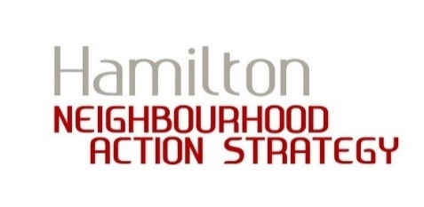
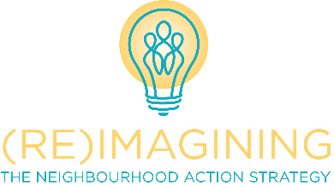
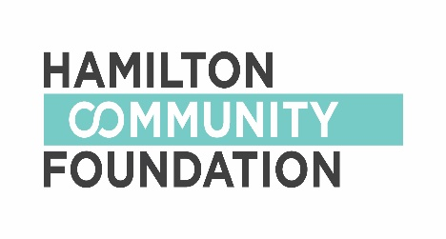

NEIGHBOURHOOD ACTION STRATEGY
SMALL GRANTS PROGRAM

FINAL REPORT

As a recipient of a NAS Small Grant, we ask that you complete this form approximately one month after your project or event has happened. With this form, please also submit your receipts.

- How did you and/or your group use this grant?

- How did your project make a difference in the neighbourhood(s)?

- In your application, we asked you to plan your initiative. Even with the best planning, things can change. That is normal. Tell us how your plans changed over time.

- What new relationships or partnerships were established as a result of working on this project?

- What was the biggest challenge your group experienced in planning and completing your project?

Estimate the number of people involved in planning this project:

Estimate the number of people who participated in this project:

Are there any outstanding monies that need to be repaid?
YES NO

If yes, how much? $

Your Feedback Wanted! (OPTIONAL)

Between April 1 and December 31, 2018, we are ‘piloting’ or ‘testing’ a new small grants toolkit. We would like to collect your feedback on the new toolkit so we can make improvements for 2019. If you would like to tell us about your experience applying for a small grant and/or completing a project, please do so below. You can also submit feedback to research@hamiltoncommunityfoundation.ca

We hope you learned a lot and made new connections
through your small grant!

