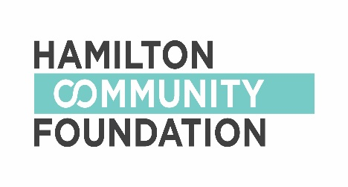
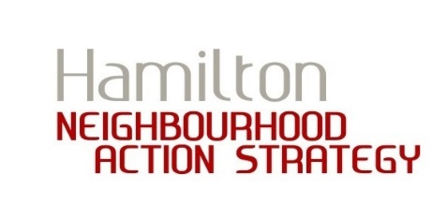

120 King Street West, Suite 700 Hamilton, Ontario L8P 4V2

SUBJECT: Letter of Agreement between

______________________________________________________________

(neighbourhood project team), _____________________________________
(fiscal sponsor) and Hamilton Community Foundation

ACTION: Please Sign and Return

Date: _________________________

To Whom It May Concern:

____________________________________, its staff and Board of Directors agree to act as the fiscal sponsor/registered charity for the Neighbourhood Action Strategy project team of

__________________________________________________________, and the work they are undertaking in support of their project,

______________________________________________, for funds received from the Hamilton Community Foundation (HCF).

It is acknowledged by agreement that _________________________________, acting as fiscal sponsor, is responsible for distribution of funds to project team in one installment, once the cheque from HCF is issued. The cheque will be made payable to

____________________________________________.

It is further acknowledged that the neighbourhood hub or planning team who approved the grant, and the Community Developer, are available when requested to provide support to the project team. They will assist with the work that is to be completed as described, within agreed time frames. The project team and Community Developer also agree to ensure that any necessary financial reporting and documentation is completed and submitted to the fiscal sponsor and to HCF.

It is also acknowledged by all parties that the Neighbourhood Action Strategy project team will be responsible for the following:
- Organizing the project and developing plans for the work to be done;
- Ensuring there are sufficient staff/volunteers to perform the work that is needed;
- In collaboration with the planning team or hub that provided the grant, completing and submitting a final report to HCF and

_______________________________ on the project by

______________________ (approximately one month after the project or event is complete).

Please sign below and return to the project team. Please keep a copy for your records.

Signed on this date: ____________________________

Neighbourhood Project Team:

_____________________________ __________________________
Signature, Primary Applicant Name (Print)

_____________________________ __________________________
Signature, Secondary Applicant Name (Print)

Community Developer:

_____________________________ __________________________
Signature Name (Print)

Fiscal Sponsor Organization:

_____________________________
Registered Charitable Number

_____________________________ __________________________
Signature Name, Title (Print)

Hamilton Community Foundation:

_____________________________ __________________________
Signature Name, Title (Print)

