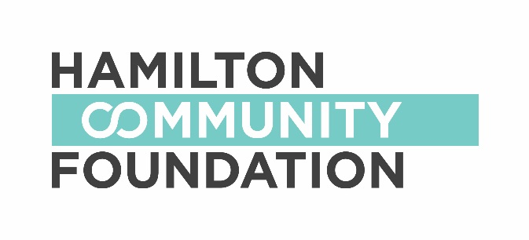

GENERAL APPLICATION FORM

2018-19

Lawyers’ Legacy for Children Fund

Focus: The purpose of the fund shall be to collectively inspire and enable children and young people to nourish and develop their knowledge, talents and values in the spirit of community, generosity and responsibility which has traditionally characterized the contributions of the lawyers of Hamilton.

Grant range: $ 10-40,000

_______________________________________________________________________________

Applicant Information:
Organization Name:
Address:

Registered Charitable Number:
Telephone: Fax: Website:
Contact Person: Position:
Telephone: Fax: E-mail:

Sponsor Information (if applicable):
Organization Name:
Address:
Registered Charitable Number:
Telephone: Fax: Website:
Contact Person: Position:
Telephone: Fax: E-mail:

Project Information:
Project Name:
Total Project Budget: $

Amount Requested: $

Proposal Summary (Please provide a 50 – 100 word summary of your funding request):

Question One:
Describe your organization / partnership, including your purpose or mission and the services you offer.

Question Two:
If you are applying for a specific project, please list the specific activities you will undertake along with timelines.

Question Three:
List the projected outcomes from this project.

Question Four:
How will this funding be used? Have you received a grant from this fund in the past?

Authorized Signatures:

We hereby make application for a grant from Hamilton Community Foundation and declare that the information provided in the application form and all required attachments are complete with no misrepresentation. We certify that this application has official approval from the organization’s Board of Directors.

_________________________________ ____________________
Signature of Board Chair Date (M/D/Y)

_________________________________
(Name – Please Print)

_________________________________ ____________________
Signature of Executive Director Date (M/D/Y)

_________________________________
(Name – Please Print)

If you have any questions or require assistance, please contact:

Sharon Charters
Manager of Grants
Hamilton Community Foundation, 120 King Street West #700, Hamilton, ON L8P 4V2
e: s.charters@hamiltoncommunityfoundation.ca / t: 905-523-5600 x 242
w: http://www.hamiltoncommunityfoundation.ca

file:///P:\Lawyers%20Legacy\application-form-for-Lawyers%20Legacy%20for%20Children-2018.docx

