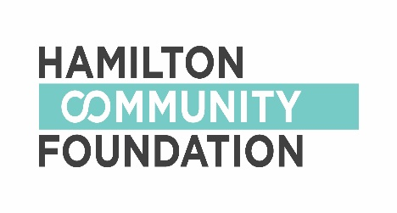
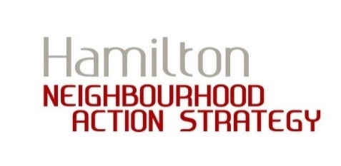

SMALL GRANTS PLAN

FOR THE PERIOD OF
JAN 2019 TO MAR 2019

Hamilton Community Foundation (HCF) is entering the next phase of its commitment to increasing the health and prosperity of neighbourhoods.
In April 2019, HCF anticipates it will roll out a new community-based small grants strategy that will reach more broadly and deeply into vulnerable communities to support projects that address health inequity.

Neighbourhoods who are part of the Neighbourhood Action Strategy (NAS) have access to their existing small grants funds until March 31, 2019. HCF is requesting a plan that outlines how each neighbourhood will spend its remaining small grants balance for the period of January 1, 2019 to March 31, 2019. For ease of access to small grants, HCF has simplified the small grants application process and created this form. Please use this as a template to complete your small grants plan instead of a full grant application. This means that grant applicants looking for funding for projects between January, 1 2019 and March 31, 2019 do not need to fill out a full application. HCF will need this plan by December 15, 2018.

Small grants are administered through the HCF, and as public foundation, HCF can only distribute grants to registered charitable organizations. Applicants must work with a fiscal sponsor who will receive the funds from HCF, and then issue those funds to the neighbourhood. In addition to the plan below, a Fiscal Sponsor Agreement must be completed for each project listed. There is a template agreement letter and more information on fiscal sponsors available at www.hamiltoncommunityfoundation.ca/NAS

HCF will be issue funds to your fiscal sponsor approximately 1 (one) month before your event. Please also check with your fiscal sponsor what their turnaround time is for issuing funds. If you would like HCF to issue funds earlier, please contact us at smallgrants@hamiltoncommunityfoundation.ca

After each project below is completed, HCF also requires that grant applicants submit a Final Report by March 31, 2019. Please also submit receipts with the final report. A copy of the Final Report Form can be found at www.hamiltoncommunityfoundation.ca/NAS

If you have any questions, please contact
smallgrants@hamiltoncommutniyfoundation.ca

A SUMMARY OF WHAT WE’LL NEED FROM YOU:

Small Grants Plan by December 15, 2018

Fiscal Sponsor Agreements for each project listed in the plan, to be submitted by December 15, 2018

Final Report and receipts for each project listed in the plan by March 31, 2019

SMALL GRANTS PLAN FOR THE PERIOD OF JANUARY 1, 2019 TO MARCH 31, 2019

Name of Neighbourhood: _________________________

Amount remaining in neighbourhood’s small grants fund as of December 31, 2018: $ ________________

Please tell us how your neighbourhood group decided which projects to fund:

Please complete a chart for each project you plan to support using your remaining small grants funds. Only complete as many charts as you need.

PROJECT/EVENT 1:
Name of Project:

Description of Project:
Date of Project or Event:

Name and Contact Information of Grant Applicant(s):

Please provide a primary contact for the project and a secondary contact in case we cannot reach the primary applicant.

Amount Requested: | $
Description of how money will be spent:

You can simply provide a list of items/services you plan to buy for your project, or provide a budget breakdown if you wish.

Fiscal Sponsor Information, including:
- Organization name
- Name of contact person and their contact information

A completed and signed Fiscal Sponsor Agreement must be submitted with this form.

PROJECT/EVENT 2:
Name of Project:

Description of Project:

Date of Project or Event:

Name and Contact Information of Grant Applicant(s):

Please provide a primary contact for the project and a secondary contact in case we cannot reach the primary applicant.

Amount Requested: | $
Description of how money will be spent:

You can simply provide a list of items/services you plan to buy for your project, or provide a budget breakdown if you wish.
Fiscal Sponsor Information, including:
- Organization name
- Name of contact person and their contact information

A completed and signed Fiscal Sponsor Agreement must be submitted with this form.

PROJECT/EVENT 3:
Name of Project:

Description of Project:

Date of Project or Event:

Name and Contact Information of Grant Applicant(s):

Please provide a primary contact for the project and a secondary contact in case we cannot reach the primary applicant.

Amount Requested: | $
Description of how money will be spent:

You can simply provide a list of items/services you plan to buy for your project, or provide a budget breakdown if you wish.
Fiscal Sponsor Information, including:
- Organization name
- Name of contact person and their contact information

A completed and signed Fiscal Sponsor Agreement must be submitted with this form.

PROJECT/EVENT 4:
Name of Project:

Description of Project:

Date of Project or Event:

Name and Contact Information of Grant Applicant(s):

Please provide a primary contact for the project and a secondary contact in case we cannot reach the primary applicant.

Amount Requested: | $
Description of how money will be spent:

You can simply provide a list of items/services you plan to buy for your project, or provide a budget breakdown if you wish.
Fiscal Sponsor Information, including:
- Organization name
- Name of contact person and their contact information

A completed and signed Fiscal Sponsor Agreement must be submitted with this form.
PROJECT/EVENT 5:
Name of Project:

Description of Project:

Date of Project or Event:

Name and Contact Information of Grant Applicant(s):

Please provide a primary contact for the project and a secondary contact in case we cannot reach the primary applicant.

Amount Requested: | $
Description of how money will be spent:

You can simply provide a list of items/services you plan to buy for your project, or provide a budget breakdown if you wish.
Fiscal Sponsor Information, including:
- Organization name
- Name of contact person and their contact information

A completed and signed Fiscal Sponsor Agreement must be submitted with this form.

PROJECT/EVENT 6:
Name of Project:

Description of Project:

Date of Project or Event:

Name and Contact Information of Grant Applicant(s):

Please provide a primary contact for the project and a secondary contact in case we cannot reach the primary applicant.

Amount Requested: | $
Description of how money will be spent:

You can simply provide a list of items/services you plan to buy for your project, or provide a budget breakdown if you wish.
Fiscal Sponsor Information, including:
- Organization name
- Name of contact person and their contact information

A completed and signed Fiscal Sponsor Agreement must be submitted with this form.

