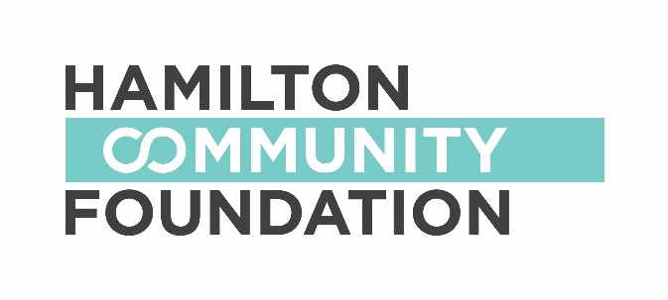
CALL FOR PROPOSALS/GUIDELINES - 2019-20
Deadline: March 1, 2019

ABACUS is an initiative of the Hamilton Community Foundation and the Fairmount Foundation aimed at supporting academic success and post-secondary access for youth experiencing multiple barriers. ABACUS is based on the understanding that decisions and supports that affect high school success and lead to participation in post-secondary education begin early in a youth’s academic life; and that successful interventions should begin as early as middle school. It is also based on research that shows this age group is currently underserved. Therefore, ABACUS will fund programs that begin in the middle- school years and focus on improving the academic, community and environmental factors that have the most direct impact on students’ likelihood of succeeding academically and ultimately attending post-secondary education.

The overall goal of ABACUS is to:
Improve high-school graduation rates and access to post-secondary education, including trades and apprenticeship opportunities, by focusing on the “middle-school years”:
Grades 6, 7, 8 and transition to 9.

Hamilton Community Foundation is entering the fourth year of its 10-year commitment to advancing post-secondary access through ABACUS. We invite charitable organizations in Hamilton to join us in continuing this work. For the 2019-20 school year, granting from the Community Fund will support education-based initiatives aimed at improving middle school years’ academic and social engagement, improving transitions from middle school to high school and laying the foundation for successful high school graduation and access to post-secondary education for disadvantaged students.

We are especially interested in programs that:

- Serve youth who have been shown to experience more barriers to success in middle school, high school graduation and post-secondary access such as low-income students, first-generation PSE attenders, Indigenous students, students from newcomer communities etc.
- Operate in partnership with other community or school supports
- Incorporate the four-pillar framework as outlined at https://www.hamiltoncommunityfoundation.ca/wp-content/uploads/2019/01/Description-of-4-Pillars-for-Grantees-Rev-Jan-9-2019.pdf
of academic upskilling, counselling/mentoring, goal setting and incentives.
- Incorporate strategies to engage parents

Organizations that are non-profit, but that do not have charitable status, may be eligible to apply under a fiscal sponsorship. Information is available at:
http://hamiltoncommunityfoundation.ca/?s=sponsorship

General criteria

- Grants for one-time special events, individual student sponsorships, or capital will not be considered.
- All initiatives must be carried out within Hamilton.
- Grants will not be made to promote political, religious, moral or ethical philosophies or for purposes which may be deemed discriminatory.
- Foundation funds are not intended to fund programs that are the responsibility of the public through the annual Board of Education budget.
- Funds are to be used during the 2019-20 school year.

Funding categories:

For 2019-20 grants will be available within three categories as described below:

- Learning Enrichment and Supports – funding range of $25,000 to $60,000
The Learning Enrichment and Supports category includes a variety of program approaches with the common goal of improving academic and social engagement among middle-school aged youth. Example approaches include:
- Learning enrichment programs offering access to experiences and opportunities to youth who may not otherwise have access and that are also connected to possible educational pathways or futures (such as experiential learning activities or positive adult role models from across industry). These programs often engage a large number of youth across multiple locations.
- Learning support programs offering more intensive and comprehensive supports (such as, mentorship, social-emotional skills development, homework help, etc.) to a smaller number of youth.

Criteria will include:
- Clear alignment with ABACUS goals and four-pillar framework
- Strong school board connection/support
- Shows promise for scaling

- Enhancement Programs – funding range $5,000 to $30,000
This category provides the opportunity to enhance existing community programs not currently funded through ABACUS, with activities/services based on the goals of ABACUS, for example, an existing recreational program looking for support to add a tutoring component.

Criteria include:
- Organizations with evidence-based, established programs that have demonstrated success and will add or increase support relevant to ABACUS goals
- Significant in-kind contribution from applicant

- Innovation Funding – funding range $5,000 to $20,000
An example of innovation could be piloting a new program or approach that works towards the goals of ABACUS. It could also be testing a novel program element, curriculum or resource within an existing program, for example, a creative way to intentionally connect parents, educators and service providers in a child’s education.

Criteria will include:
- Piloting a new idea or new ways of meeting identified needs
- May offer a support/opportunity beyond the four pillar framework

Proposal assessment:

These criteria will be used to assess all applications for support from ABACUS:

- Direct relevance to fund priorities
- Interest and commitment to partner with HCF on ABACUS and four-pillar framework
- Demonstrated capacity to plan and implement the work within the funding period
- Demonstrated need for program, clarity in program model and compelling rationale for the approach proposed
- Sound fiscal policies and a commitment to financial accountability
- Appropriate and feasible evaluation plan including realistic, measurable goals and a commitment to ongoing evaluation aimed at continuous improvement and measuring impact.
- Potential to leverage additional financial support
- Clear and reasonable budget
- Level of co-operation and collaboration and consultation with other groups that could contribute to improved results in the project, i.e. evidence of school board, parent and/or community support
- Shows promise for scaling, i.e. replication, systems or cultural change
- Need for Hamilton Community Foundation funding
- Projects should encourage collaboration and create an impact beyond the funding period

Successful applicants will expected to participate in evaluation and information sharing activities as requested by HCF.

For more information about ABACUS and to submit an on-line application, please visit:
http://hamiltoncommunityfoundation.ca/grants/grant/abacus-advancing-post-secondary-access/

Contact Information:

Sharon Charters, Manager of Grants
Hamilton Community Foundation, 120 King Street West, Suite 700,
Hamilton, Ontario, L8P 4V2
Phone: (905) 523-5600 Ext. 242 Fax: (905) 523-0741
Website: www.hamiltoncommunityfoundation.ca
E-mail: s.charters@hamiltoncommunityfoundation.ca

