THE ONTARIO ENDOWMENT

FOR CHILDREN & YOUTH

IN RECREATION FUND: 2017-18
APPLICATION FORM–PART 1 OF 2
Due Date: May 5, 2019
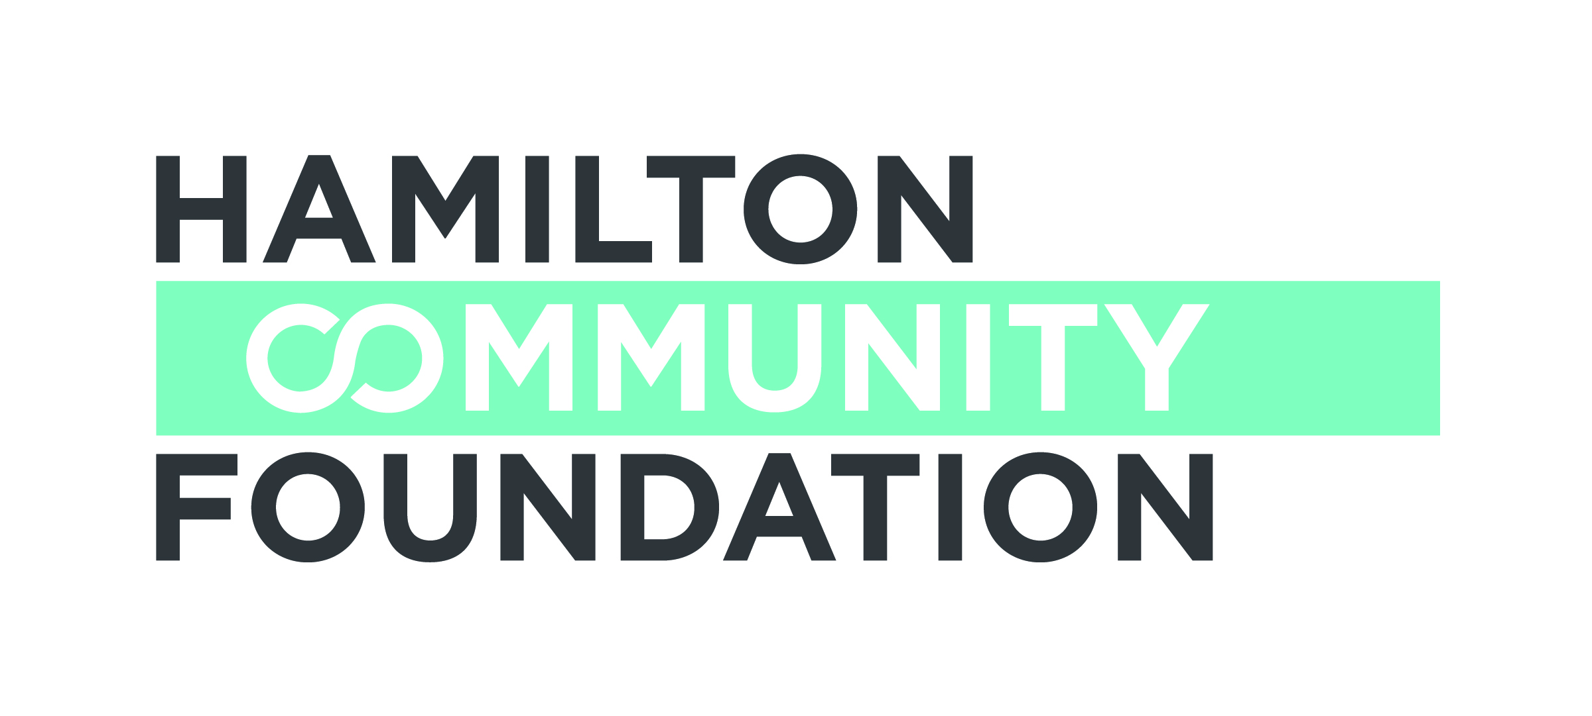

In order for your application to go forward, signatures on this form must be of those persons from the organization holding charitable status.

Two complete copies of the application (including all supporting documentation)

A list of current Board members

A copy of the project budget

A copy of the organization’s operating budget for the current year

A copy of the most recent audited financial statements

Signature of the Chair of the Board of Directors and the Executive Director
indicating authorization of the application by your organization’s Board of
Directors

A signed copy of the partnership agreement between the applicant and the
sponsoring agency, if applicable

_______________________________ ________________________________
Signature, Executive Director of Name /Title (print)
Applicant*

_______________________________ _______________________________
Signature, Chair, Board of Directors Name /Title (print)
of Applicant*

*In the event of a sponsorship, the Executive Director and Board Chair of the organization holding charitable status must sign this Application

THE ONTARIO ENDOWMENT

FOR CHILDREN & YOUTH

IN RECREATION FUND: 2017-18
APPLICATION FORM–PART 2 OF 2
Due Date: May 5, 2019

Applicant Information:
Organization Name:
Address:

Registered Charitable Number:
Telephone: Fax: Website:
Contact Person: Position:
Telephone: Fax: E-mail:

Sponsor Information (if applicable):
Organization Name:
Address:
Registered Charitable Number:
Telephone: Fax: Website:
Contact Person: Position:
Telephone: Fax: E-mail:
Note: A completed and signed Partnership Agreement must be submitted with the application.

Project Information:
Project Name:
Total Project Budget: $

Amount Requested: $
Start and Completion Date of Project:

Proposal Summary (Please provide a 50 – 100 word summary of your funding request.)

Section A: Organization / Partnership

- Describe your organization / partnership, including your purpose or mission, and your organizational structure.

- Tell us why you are best suited to do the proposed initiative and how you will work with others.

Section B: Community Involvement

- Clearly describe the community or population to be served by this application.

- Is your project accessible to anyone interested in participating? Do any barriers exist that might prevent some people from participating? If so, how do you work to eliminate those barriers?

Section C: Project
- What is the need your project aims to address?

- What is your proposed solution to meet the need? What activities will you undertake. Please include timelines. How many children/youth do you anticipate participating/serving?

- How is the community or population you serve involved in the design, implementation and evaluation of the project? What other community organizations or partners will be involved in this program and how will they be involved?

8. Clearly list the projected outcomes from this project.

Section D: Sustainability

9. How will the impact of your project continue into the future? What resources will
be required to sustain the impact, if any?

Section E: Financial Information

- Requested Budget

Item | Details | Amount ($)
Total Amount

11. Other Sources of Funding

Source  Organization  Contact Name  Contact Number | Item / Details | Amount | In Kind  or  Financial | Anticipated  or  Confirmed
TOTAL

Section F: Authorized Signatures

We hereby make application for a Hamilton Community Foundation Ontario Endowment for Children and Youth grant and declare that the information provided in the application form and all required attachments are complete with no misrepresentation

We understand that submission of this application will not necessarily result in funding support from the Hamilton Community Foundation. Furthermore, we understand that applications may be funded in full or in part, and with some conditions. We understand that staff and volunteers of the Hamilton Community Foundation will review our application.

We certify that this application has official approval from the Board of Directors of the applicant organization.

______________________________ _________________________________
Signature, Executive Director of Name /Title (print)
Applicant*

______________________________ _________________________________
Signature, Chair, Board of Directors Name /Title (print)
of Applicant*

*In the event of a sponsorship, the Executive Director and Board Chair of the organization holding charitable status must sign this Application

If you have any questions or require assistance, please contact

Sharon Charters at: (905) 523-5600 x 242 / s.charters@hamiltoncommunityfoundation.ca
This application form may be downloaded from our website www.hamiltoncommunityfoundation.ca

Applications must be submitted to the Foundation office,
Suite 700, 120 King Street West, Hamilton, ON L8P 4V2 in HARD COPY ONLY. Submissions via email or facsimile will not be considered.
Hamilton Community Foundation, 120 King Street West #700, Hamilton, Ontario L8P 4V2
Telephone:(905) 523-5600 • Fax:(905) 523-0741 • www.hamiltoncommunityfoundation.ca

